# Google Earth

Manoj Kumar Yejjala

**Task-1**

**Greatest width and length of the lakes:**

|  |  |  |
| --- | --- | --- |
| Lakes | Greatest Width | Greatest Length |
| Hicks Lake | 636 mts | 1434 mts |
| Todd Lake | 687 mts | 728 mts |
| Wells Lake | 385 mts | 574 mts |

**Approximate surface area of the lakes in square meters and acres:**

|  |  |  |
| --- | --- | --- |
| Lakes | Surface area (Sq mts) | Surface area (acres) |
| Hicks Lake | 594,471 sq mts | 147 acres |
| Todd Lake | 288,592 sq mts | 71.3 acres |
| Wells Lake | 183,695 sq mts | 45.4 acres |

**Description of lakes with geographical coordinates:**

**Hicks Lake:**

The latitude value (44° 1’ 22.47" N) indicates that the location is approximately 44.02 degrees north of the equator. The longitude value (85° 16’ 59.70" W) indicates that the location is approximately 85.28 degrees west of the Prime Meridian, which passes through Greenwich, London.

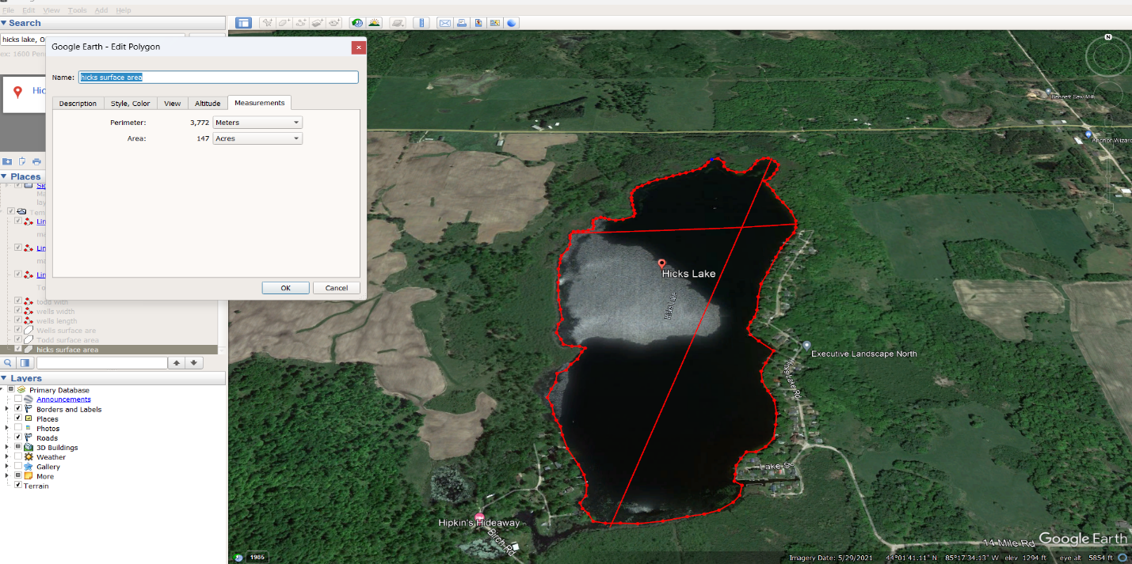

**Todd Lake:**

The latitude value (43° 56’ 57.98" N) indicates that the location is approximately 43.95 degrees north of the equator. The longitude value (85° 27’ 17.35" W) indicates that the location is approximately 85.45 degrees west of the Prime Meridian, which passes through Greenwich, London.

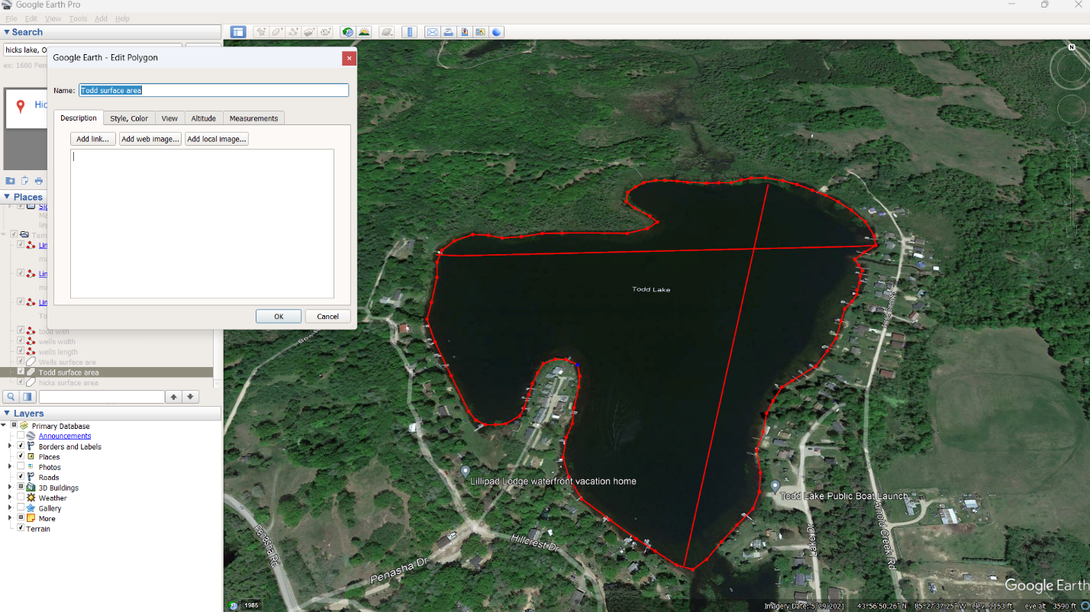

**Wells Lake:**

The latitude value (43° 59’ 48.75" N) indicates that the location is approximately 43.99 degrees north of the equator. The longitude value (85° 24’ 54.07" W) indicates that the location is approximately 85.41 degrees west of the Prime Meridian, which passes through Greenwich, London.

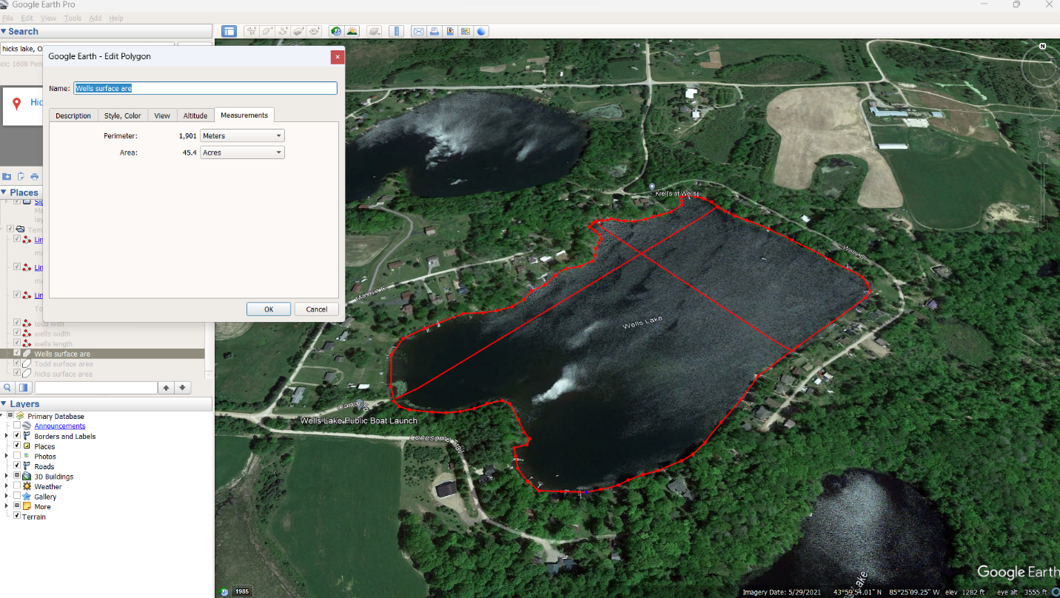

**Latitude, longitude and elevation of the Lakes:Bottom of Form**

|  |  |  |  |
| --- | --- | --- | --- |
| Lakes | Latitude | Longitude | Elevation |
| Hicks Lake | 44° 1'22.47"N | 85°16'59.70"W | 1259 ft |
| Todd Lake | 43°56'57.98"N | 85°27'17.35"W | 1123 ft |
| Wells Lake | 43°59'48.75"N | 85°24'54.07"W | 1235 ft |

**Explanation about what baselines and measures latitude and longitude are base on:**

Latitude and longitude are integral components of a coordinate system employed to ascertain the precise positions of points on the Earth's surface.

Latitude lines, known as parallels, extend horizontally from east to west and are consistently equidistant from one other. They quantify the distance in the north or south direction from the equator. The latitude of a location is the angular distance, given in degrees, between that place and the equator along a meridian, or line of longitude. The equator is situated at a latitude of 0°, whereas the North and South Poles are positioned at latitudes of 90° north and 90° south respectively.

Meridians, known as longitude lines, extend in a north-south direction. They quantify the distance in the east or west direction from the prime meridian. The longitude of a location refers to the angular distance, measured in degrees, between that point and the prime meridian along a parallel. The prime meridian traverses the former Royal Observatory located in Greenwich, England, and is occasionally denoted as the Greenwich meridian.

Latitude is a measure of a location's distance from the equator in the north or south direction, whereas longitude is a measure of a location's distance from the prime meridian in the east or west direction.

Task-2

Geographic Location of Lunar landing sites:

Apollo 11: Located in the southwestern region of Mare Tranquilities, the site is situated around 400 meters west of West crater and approximately 20 kilometers south-southwest of the crater Sabine D.

Apollo 12: The Apollo 12 landing site, shown by a green cross, is located in the southeastern region of Oceanus Procellarum. It has resemblance to the initial landing location of the Apollo missions.

Apollo 14: The Apollo 14 spacecraft touched down in the Fra Mauro Formation.

Apollo 15: The Hadley-Apennine region, located on the near side of Earth's Moon, was chosen as the designated landing site for the American Apollo 15 mission.

Apollo 16: The Descartes Highlands are located at coordinates 8.97301°S latitude and 15.50019°E longitude.

Apollo 17: The landing zone, referred to as the Taurus Mountains and Littrow Crater, is located slightly beyond the southeastern border of the Mare Serenitatis. It is situated at a latitude of around 20 degrees north and a longitude of 30 degrees east.

Proposed first Artemis lunar landing site:

The region poleward of 84° south latitude.

Chandrayaan-3 Site:

The Chandrayaan-3 landing site is located about 600 km from the south pole (69.3741°S Latitude, 32.32°E Longitude, 532 m elevation)

**Using geographic coordinates of the Apollo 11 landing site, where would that be on Earth?**

The approximate the location on Earth, it would in the country Democratic Republic of Congo, 109 kilometers away from nearest town Yangambi.

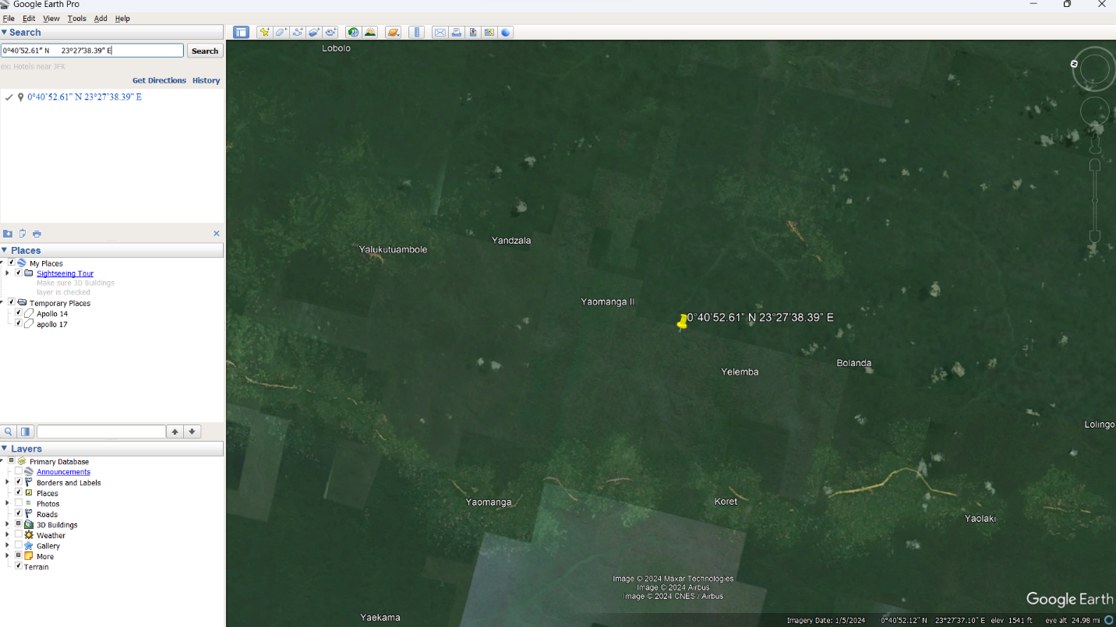

Geographic surface area (aprox.) of each Apollo Mission:

|  |  |
| --- | --- |
| Apollo Mission | Surface area in Sq mts |
| Apollo 11 | 9,037 |
| Apollo 12 | 85,232 |
| Apollo 14 | 97,586 |
| Apollo 15 | 1,500,899 |
| Apollo 16 | 1,939,433 |
| Apollo 17 | 10,344,028 |

Distance between landing sites:

|  |  |
| --- | --- |
| Missions | Distance in Kms |
| Apollo 11- Apollo 12 | 1426.44 |
| Apollo 12- Apollo 14 | 181.61 |
| Apollo 14- Apollo 15 | 1096.67 |
| Apollo 15- Apollo 16 | 1118.13 |
| Apollo 16- Apollo 17 | 993.65 |

Representation of relative landing site locations:

|  |  |
| --- | --- |
| Apollo Mission | Lunar landing sites |
| Apollo 11 | Southwestern edge of the Mare Tranquillitatis |
| Apollo 12 | Surveyor 3 spacecraft in the region of Oceanus Procellarum |
| Apollo 14 | Fra Mauro highlands |
| Apollo 15 | Hadley-Apennine region |
| Apollo 16 | Descartes Highlands |
| Apollo 17 | Taurus-Littrow Valley |

**Little West Crater and Double Crater dimensions:**

|  |  |  |  |
| --- | --- | --- | --- |
| **Crater** | **Length in Mts** | **Width in Mts** | **Area in Sq mts** |
| Little West Crater | 45.2 | 36.4 | 1,127 |
| Double Crater | 17.3 | 17.1 | 213 |

**Head Crater dimensions:**

|  |  |  |  |
| --- | --- | --- | --- |
| **Crater** | **Length in Mts** | **Width in Mts** | **Area in Sq mts** |
| Head Crater | 111 | 106 | 8,958 |

Weird Rock:

The Genesis Rock, unearthed during the Apollo 15 mission, is a singular lunar specimen. Comprised of anorthosite, an ancient volcanic rock, it provides valuable insight into the Moon's early history, believed to have originated some 4 billion years ago. The rock's composition indicates that it underwent intense thermal events in the past, potentially resulting from collisions or volcanic activity. It is named due of its significance in comprehending the progression of the moon. Derived from the Apennine Mountains, this rock has played a vital role in augmenting our comprehension of the Moon's geological mechanisms and its formation during the initial stages of the solar system.

Rima Hadley:

Rima Hadley is a sinuous lunar rille that is associated with previous volcanic activity and is situated in proximity to the Apennine Mountains on the Moon. The examination of this feature was particularly notable during the Apollo 15 mission in 1971, when astronauts David Scott and James Irwin landed in close proximity to it. The location holds great significance in the realms of lunar geology and volcanic history research. The employment of the Lunar Roving Vehicle during Apollo 15 facilitated thorough investigation, yielding significant samples and data. The Rima Hadley site is an important location that enhances our understanding of the Moon's geological evolution and offers crucial insights into its past volcanic processes.

Story behind Ballet Crater:

During Geology Station 3, the Apollo 17 crew were instructed to locate a crater that had removed material from the bottom of Lincoln Scarp and to gather samples of this material, including a core sample. Consequently, the astronauts selected a crater with a diameter of 10 meters located near the scarp, which was encompassed by rocks that had an average size of half a meter.

During the process of Cernan extracting the core sample, Schmitt was assigned the task of collecting rock samples independently. It was exasperating - he continuously fumbled his scoop while transferring the samples into small collecting bags, and his bag dispenser had abruptly ceased functioning! While placing samples into the spacious collection bag, he accidentally toppled it and stumbled while attempting to gather the dispersed samples.

Mission Control attempted to alleviate Schmitt's agitated mood by jokingly informing him that the Houston Ballet Foundation had been contacting them to request his services for the upcoming season. Schmitt displayed his wit by extending his right leg backwards and hopping on his left leg momentarily as a little "audition." The site was named Ballet Crater as a tribute to Schmitt's elegance.

Path travelled during each mission:

|  |  |
| --- | --- |
| Apollo Mission | Length in Mts |
| Apollo 11 | 420 |
| Apollo 12 | 1,808 |
| Apollo 14 | 3,655 |
| Apollo 15 | 22,797 |
| Apollo 16 | 21,813 |
| Apollo 17 | 30,894 |

Geographic coordinates of each landing site:

|  |  |  |
| --- | --- | --- |
| Apollo Mission | Latitude | Longitude |
| Apollo 11 | 0°40’52.61” N | 23°27’38.39” E |
| Apollo 12 | 3°01’32.70” S | 23°27’58.64” W |
| Apollo 14 | 3°38’42.72” S | 17°28’37.80” W |
| Apollo 15 | 26°05’39.68” N | 3°37’14.13” E |
| Apollo 16 | 8°58’12.73” S | 15°26’46.56” E |
| Apollo 17 | 20°11’46.53” N | 30°42’06.49” E |

Distance between each in kilometers:

|  |  |  |  |  |  |  |
| --- | --- | --- | --- | --- | --- | --- |
| Mission | Apollo 11 | Apollo 12 | Apollo 14 | Apollo 15 | Apollo 16 | Apollo 17 |
| Apollo 11 |  | 1426 km | 1248 km | 965 km | 379 km | 630 km |
| Apollo 12 | 1426 km |  | 181 km | 1188 km | 1187 km | 1758 km |
| Apollo 14 | 1248 km | 181 km |  | 1095 km | 1007 km | 1607 km |
| Apollo 15 | 965 km | 1188 km | 1095 km |  | 1119 km | 776 km |
| Apollo 16 | 379 km | 1187 km | 1007 km | 1119 km |  | 995 km |
| Apollo 17 | 630 km | 1758 km | 1607 km | 776 km | 995 km |  |

**Latitude, longitude and approximate elevation:**

|  |  |  |  |
| --- | --- | --- | --- |
| Apollo Mission | Latitude | Longitude | Elevation |
| Apollo 11 | 0°40’53.31” N | 23°27’34.51” E | -1924m |
| Apollo 12 | 3°01’29.64” S | 23°27’44.85” W | -1427m |
| Apollo 14 | 3°39’06.00” S | 17°29’41.96” W | -1021m |
| Apollo 15 | 26°07’45.59” N | 3°37’59.95” E | -1847m |
| Apollo 16 | 8°59’25.01” S | 15°28’21.50” E | 420m |
| Apollo 17 | 20°11’33.00” N | 30°46’09.36” E | -2353m |

Apollo 11 is the inaugural expedition with human presence that successfully reached the lunar surface. To achieve this, they employed state-of-the-art technology and implemented the most advanced measures available at that time. The main goal is to execute a manned lunar landing and safely return to Earth.

Experimental data and details:

Experiments conducted on the Lunar Module:

The Apollo 11 lunar module, known as Eagle, transported a variety of scientific instruments. The equipment consists of a seismometer for measuring moonquakes and a retroreflector array for conducting laser ranging studies. Solar Wind Composition Experiment: It involves gathering particles from the solar wind to gain knowledge about the composition of the sun.

Lunar Sample Collection: - The crew gathered geological specimens consisting of rocks and soil from the lunar surface. These instruments are utilized to investigate the geology of moons and gather crucial data regarding the early solar system.

Details pertaining to activities:

Lunar Extravehicular Activity (EVA): Neil Armstrong and Buzz Aldrin performed a momentous lunar excursion on July 20, 1969. Armstrong uttered his renowned phrase "That's one small step for a man, one giant leap for mankind" while setting foot on the lunar surface.

Engaging in flag planting and establishing experimental setups.

Camera-related information:

They utilized various types of high-resolution sensor-equipped cameras for the task.

One category is the Television Camera, which is used to send real-time photographs of the moonwalk to Earth.

Hasselblad Cameras will be utilized to obtain still photos of the lunar surface, as well as document activities and the crew.

The Data Acquisition Camera is installed on the window of lunar modules to capture photographs for technical and scientific research.

**Task-3**

Outcome 1: Objectives of Geographic Information Systems (GIS) Choices

Geographic Information Systems (GIS) are very effective instruments utilized for the acquisition, retention, verification, and visualization of data pertaining to locations on the Earth's surface. Maps have the capability to display a wide range of data, including streets, buildings, and plants. This allows individuals to visually see, examine, and comprehend various patterns and connections more effortlessly.

Typical functionalities and uses of GIS technology encompass:

Data Visualization: Geographic Information Systems (GIS) have the capability to visually represent data such as population density, land use, and transportation networks, allowing us to observe and analyze the interrelationships between these variables.

Spatial analysis: GIS facilitates enhanced comprehension of spatial patterns and interconnections for individuals and organizations. For instance, it can assist in identifying an optimal site for building an airport, nuclear facility, or military installation. GIS, or Geographic Information System, is an invaluable tool for managing resources in the field of agriculture. The system utilizes data pertaining to farms, weather conditions, and water supplies in order to ascertain the optimal agricultural methodologies.

Urban Planning & Transportation: GIS may also determine the most efficient routes, identify optimal locations for enterprises, define service areas, generate viewsheds to visualize line-of-sight maps, and conduct various statistical and cartographic operations.

Outcome 2: Evaluation of Tools and Technologies for Geographic Information Systems (GIS)

Google Earth is a widely utilized tool for Geographic Information System (GIS) applications. Users can get high-resolution aerial and satellite imagery, elevation terrain, road and street labels, business listings, and many features. Nevertheless, it has faced criticism for not meeting the criteria of a genuine Geographic Information System (GIS) due to its limited analytical functionalities compared to other GIS applications.

Additional tools and technologies for Geographic Information Systems (GIS) encompass:

Esri ArcGIS is a powerful platform that provides a diverse array of Geographic Information System (GIS) features.

QGIS is a cost-free, open-source software for desktop computers that offers a robust alternative to Google Earth for the visualization and analysis of geographical data.

OpenStreetMap (OSM) is a cooperative initiative that generates a costless, modifiable representation of the entire globe.

NASA World Wind is an API for virtual globes that is open source.

Zoom Earth is an interactive internet-based map that displays weather conditions worldwide and provides real-time tracking of hurricanes.

Each tool possesses unique advantages and disadvantages, and the selection of a tool would be contingent upon the precise demands of the GIS task at hand.